Name: Shay Walker

Box #613

Professor Sabal

Cairn University School of Business

CIS122 Essentials of Networking

Project #8

Project objective:

Effectively and efficiently set up and configure a virtual private network between a Linux machine and a windows machine with firewalls. (Linux to Windows) The two computers being on different private subnets and the firewall connected to each other’s public IP address.

Equipment used:

|  |  |  |  |  |
| --- | --- | --- | --- | --- |
| Equipment Description | Vendor | Vendor Item # | Retail price | Actual price (if known) |
| Barracuda NextGen Firewall X-Series X100 - firewall (x2) | Zones | 001293667 | $1,409.99 |  |
| Lenovo ThinkCentre M800z - all-in-one - Core i3 6100 3.7 GHz - 4 GB - 500 GB - LED 21.5" (x2) | Zones | 003446803 | $873.99 |  |
|  |  |  |  |  |

Detailed list of software and operating platforms used, including version numbers and licensing requirements: N/A Linux OS, Windows OS

Network diagram:

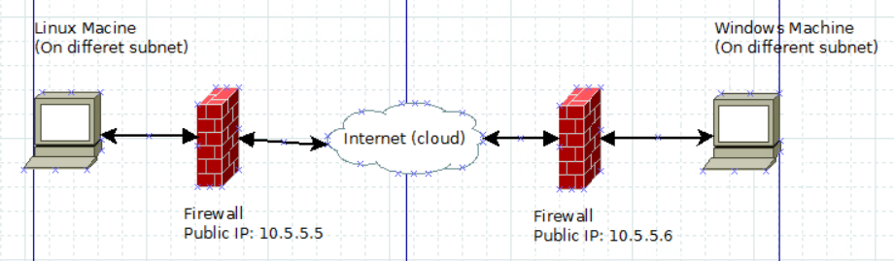

Configuration:

1. Launch management console

* Go to Configuration (Interfaces) and select the outside option and edit
* Change the Firewall IP (public) to what is desired accordingly
* Click Apply changes

1. Add Static Route

* Interface outside
* Network select the IP address you are using
* Gateway IP enter the IP address you are searching for to make the connection
* Select tunneled default for VPN
* Click Apply

1. Go to monitor to check if it is working
2. Site-to-Site VPN

* Add IPs to the Site-to-Site Connection Profile
* Enter peer IP (IP address of who it is going to)
* Enter Connection name
* Enter Pre-Shared Key
* Enter Local Network
* Enter Remote IP address

1. Go to Tools to Packet Tracker to Enter…

* Source IP
* Destination IP
* Source Port (48215)
* Destination Port (80)

If no VPN you may have a routing problem

* Change to outside

If still no VPN you may have a routing table problem

1. Change State Route

* Change gateway IP
* Click apply